|  |  |
| --- | --- |
|  | **2013** |
|  | Evert Geldenhuys |

|  |
| --- |
| **[Fun with Cars – User Manual]** |
| [Type the abstract of the document here. The abstract is typically a short summary of the contents of the document. Type the abstract of the document here. The abstract is typically a short summary of the contents of the document.] |

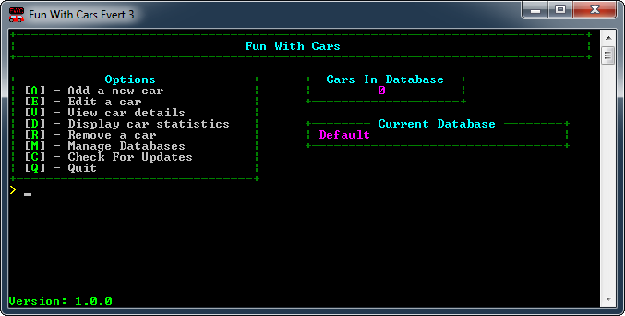

Contents

Contents

[Main Menu 2](#_Toc355981139)

[Adding a car 3](#_Toc355981140)

[Change a car’s details 4](#_Toc355981141)

[View a car’s details 5](#_Toc355981142)

[Car Statistics 6](#_Toc355981143)

[Removing a car 7](#_Toc355981144)

[Databases 8](#_Toc355981145)

[Adding a new database 9](#_Toc355981146)

[Loading an existing database 10](#_Toc355981147)

[Deleting a database 11](#_Toc355981148)

[Checking for updates 12](#_Toc355981149)

[Troubleshooting 13](#_Toc355981150)

# Main Menu

****

The Main Menu is the Main Screen of the program. All features can be accessed from this screen.

**Options**

The Options are other screens and functions that can be accessed. Their corresponding key is shown to the left of each entry inside the brackets [ ].

Pressing these keys on the keyboard will display the corresponding screen or action.

**Cars In Database**

This box displays how many cars there are in the current database. There can be a maximum of 250 cars per database.

**Current Database**

This box displays the name of the currently open database.

# C:\Users\Evert\Pictures\Screenshots\2013\05\Greenshot_000241.pngAdding a car

Main Menu 🡪 [A] – Add a new car

On this screen you can add a new car to the currently open database.

**Details Required**

Brand: This is the brand of the car. E.G: Holden

Make: The make of the car. E.G: Cruze

Model: The car model. E.G: 1.5 i 16V AWD AT

Year: The year the car was manufactured. E.G: 2013

Base Cost: The base cost of the car. E.G: 19490

Dealer Mark-up Percentage: The dealer mark-up percentage. E.G: 3 for 3%

# Change a car’s details

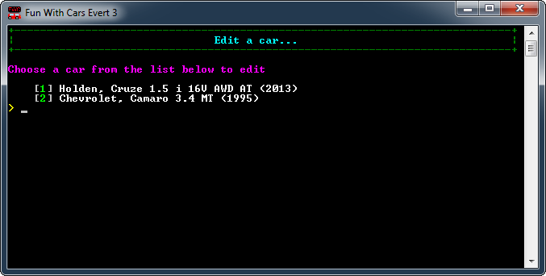

Main Menu 🡪 [E] – Edit a car

This allows you to change the details of a car.

Firstly you need to select which car you want to edit. If you want to return to the main menu without editing a car press ENTER at this screen.

Type the number displayed to the left of the car name (inside the Brackets [ ]) and press enter. For Example to edit the Chevrolet Camaro 3.4 MT (1995) you would type in “2” and press enter. This will take you to the screen to edit the car’s information.

The information required will be displayed one line at a time. If the displayed information does not require editing press ENTER for the next line to be displayed. If the information needs to be changed use BACKSPACE to erase the information and type the new information. Press ENTER when you are done editing a field. Changes will be displayed in green.

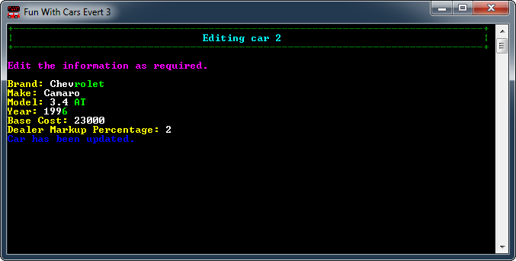

After the Car has been updated press any key to return to the Main Menu.

# C:\Users\Evert\Pictures\Screenshots\2013\05\Greenshot_000245.pngView a car’s details

Main Menu 🡪 [V] – View Car Details.

This will display the information on the chosen car. It will also allow you to calculate the income and profit for the car.

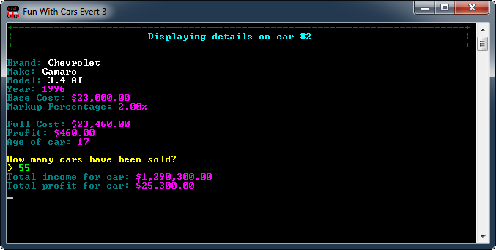Firstly you have to select which car you want to edit. Type the corresponding number of the car into the console and press enter. The following screen will appear.

At this stage you can enter the number of cars sold to calculate the profit and income or press ENTER to return to the Main Menu.

# Car Statistics

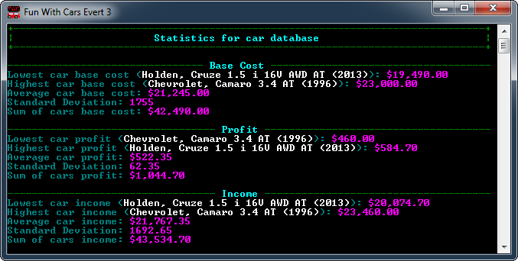Main Menu 🡪 [D] – Display Car Statistics

This Screen displayed statistics on all the cars in the currently open database.

Profit = Base Cost x Dealer Markup Percentage.

Income = Profit + Base Cost.

Press any key to return to the main menu.

# C:\Users\Evert\Pictures\Screenshots\2013\05\Greenshot_000249.pngRemoving a car

Main Menu 🡪 [R] – Remove A Car

Select the car you wish to delete by typing in its corresponding number.

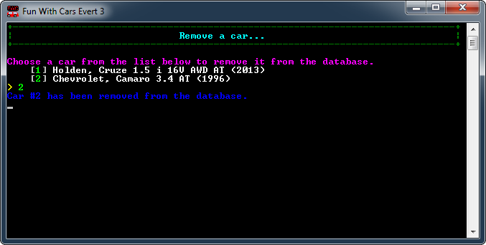Once a car is deleted it cannot be undone.

# C:\Users\Evert\Pictures\Screenshots\2013\05\Greenshot_000251.pngDatabases

Main Menu 🡪 [M] – Manage Databases.

This is the Menu for managing databases. You can create a new database, Load an existing database, or Delete a database.

Databases are useful when you want to group certain cars together. For Example you might have a database called “Favourite Cars” and another one called “Holdens”. This allows you to view the statistics of each group individually.

# C:\Users\Evert\Pictures\Screenshots\2013\05\Greenshot_000252.pngAdding a new database

Main Menu 🡪 [M] – Manage Databases 🡪 [N] – Create a new database

This screen allows you to create a new database. Simply enter the name you desire and press ENTER. This will create a new database and immediately set it as the active database. Press any key to return to the Main Menu.

# Loading an existing database

# C:\Users\Evert\Pictures\Screenshots\2013\05\Greenshot_000253.pngDeleting a database

Main Menu 🡪 [M] – Manage Databases 🡪 [D] – Delete a database

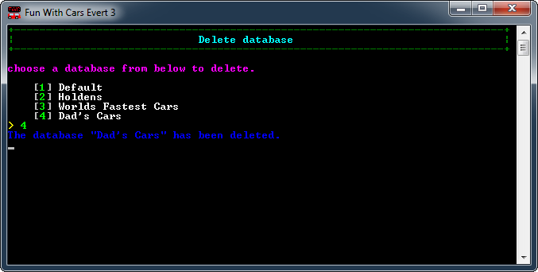This screen allows you to delete a database. Simply type in the database’s corresponding number and press ENTER.

Please note that the default database cannot be deleted.

# Checking for updates

From time to time new version of the program will be released. They often include new features, improvements and bug fixes so it is recommended to download them as soon as they become available.

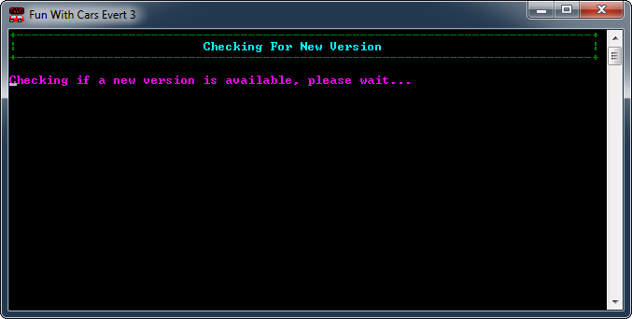The new version will be downloaded to the current directory with the version number included in the file name.

Main Menu –> [C] – Check for updates.

This screen will check if there is an update available, if there is you will be prompted if you want to download the latest version.

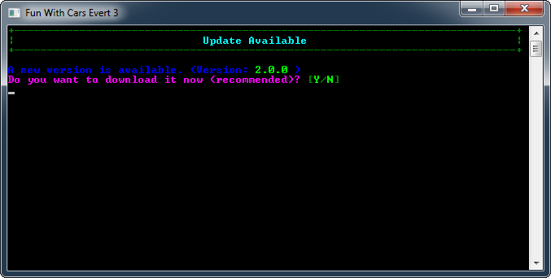Downloading updates is quick and requires no interaction.

Press the Y key to download the new version, or press the N key to download at a later time.

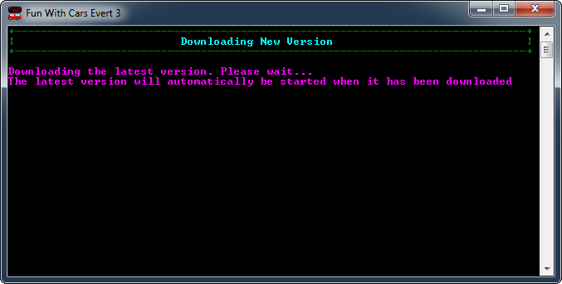Pressing the Y key will bring up the following screen:

When the update is finished downloading the program will close and the latest version of the program will automatically be launched.

# Troubleshooting

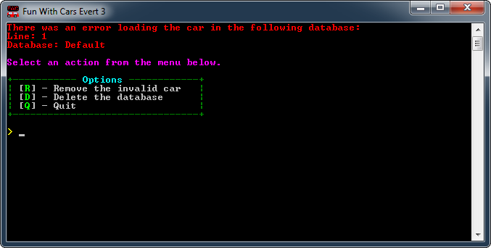An error may occur when the cars in the database is not saved in the correct format. This could occur when the database file has been edited manually. The following screen will appear if this is the case:

**Options**

[R] – Remove the invalid car: This will only delete the car that contains errors.

[D] – Delete the database: This will delete the entire database and all cars in it. It is recommended to only use this if a large number of cars are corrupt.

[Q] – Quit: This closes the program and takes no action. Do this if you want to try and manually fix the database.